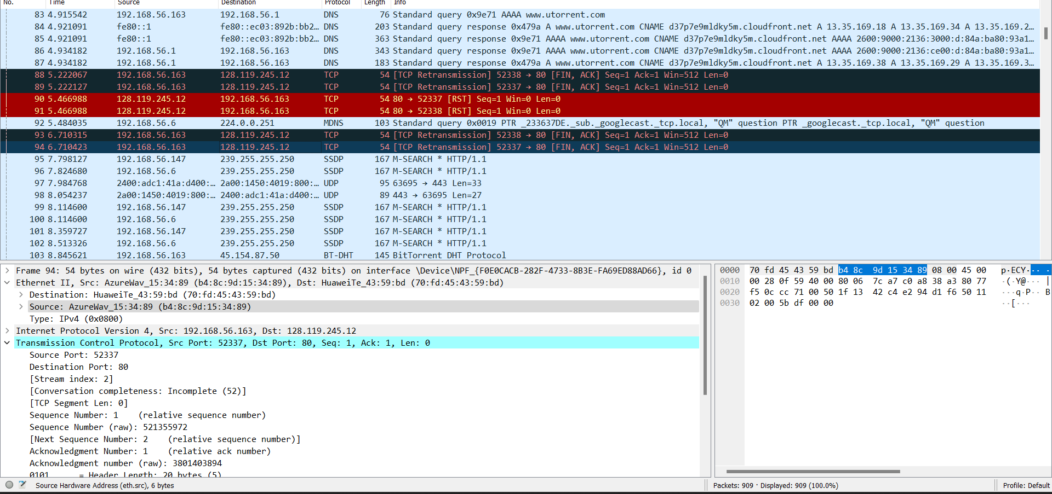



# Question 1

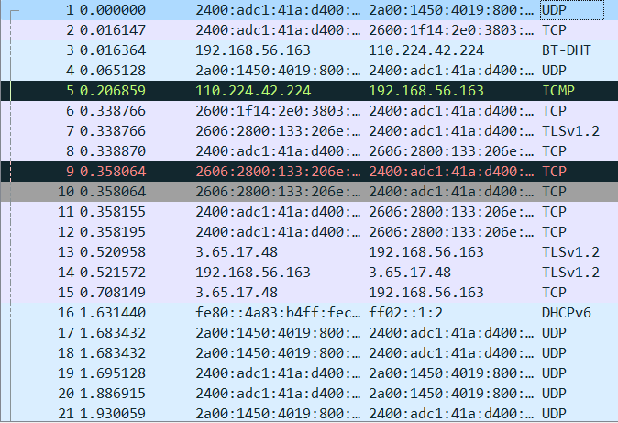

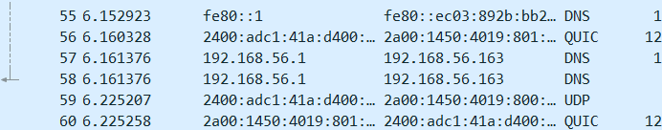





1. UDP
2. TCP
3. BT-DHT
4. ICMP
5. TLSv2.1
6. DHCPv6
7. DNS
8. QUIC
9. SSDP
10. ARP

# Question 2



Ss 51.773686 was when OK was sent and 51.480616 was when get request was sent. The time taken was 51.773686-51.480616🡺0.29307 seconds. 293 milli seconds.

# Question 3

Of gaia:128.119.245.12

Of my computer:192.168.56.163



# Question 4

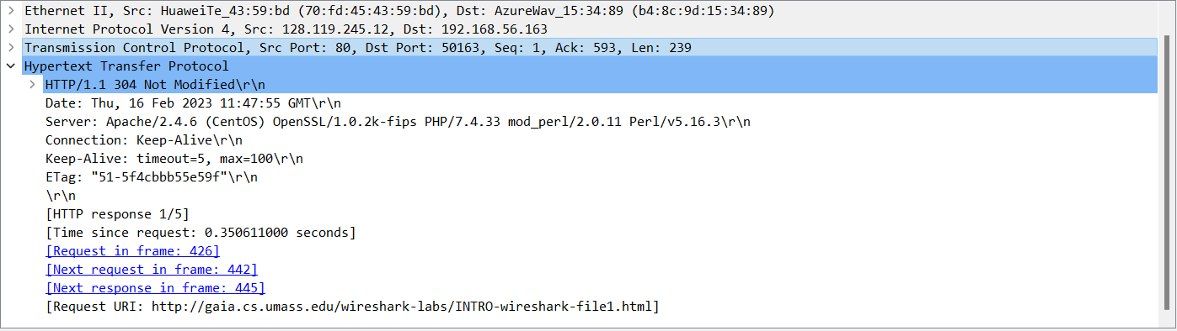

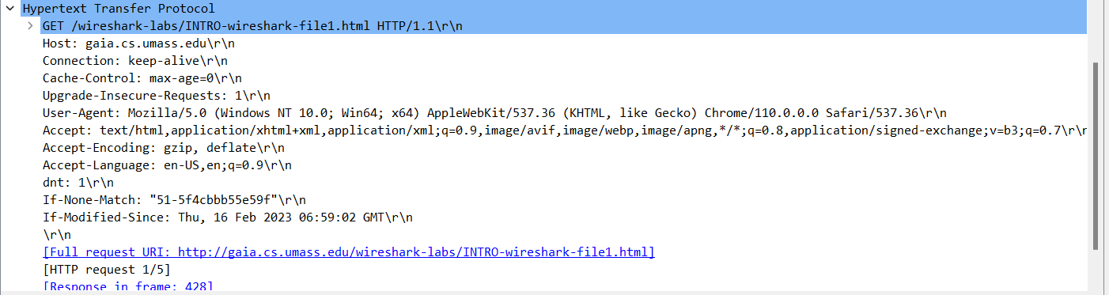

The 304 just denotes that nothing has changed since last time site was accessed. It is still OK.